Ilminster Youth Theatre

T-Shirt Order Form

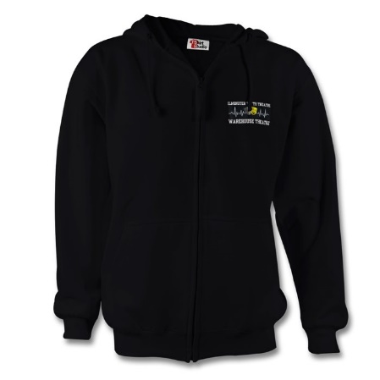

T-Shirts

Adult sizes £11.00 each

S ……………………..

M ……………………

L ………………………

T-shirts

Child sizes £8.00 each

Age 7-8 ……………………

Age 9-11 ……………………

Age 12-14 ……………………

Hoodies Adult sizes £25 each

S ………………

M ………………

L ………………..

Hoodies £18.00 each

Age 7-8 ……………

Age 9-11 ……………..

Age 12-14 ……………….

Name ………………………………………. Youth Theatre Group ………………….

Total amount payable ……………………………….

Please pay by BACS Lloyds Acc. Name: **IES Ltd.** Sort Code **30-92-40** Acc. No. **00846871**

**Please email this form with your order to lucydriver2000@gmail.com**